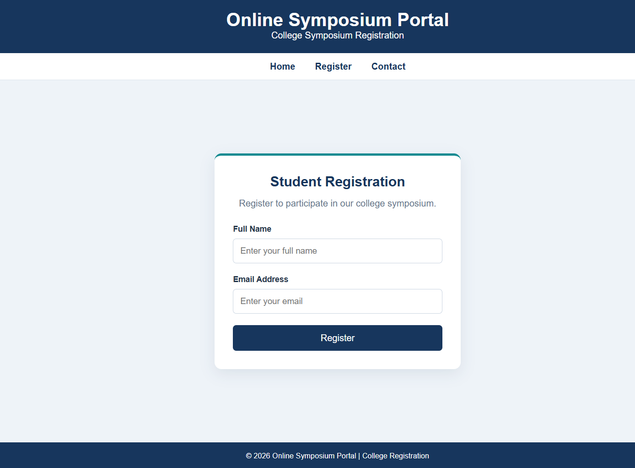

<!DOCTYPE html>
<html lang="en">
<head>
<meta charset="UTF-8">
<meta name="viewport" content="width=device-width, initial-scale=1.0">
<title>Online Symposium Portal</title>

<style>
* {
margin: 0;
padding: 0;
box-sizing: border-box;
}

body {
font-family: Arial, sans-serif;
min-height: 100vh;
display: flex;
flex-direction: column;
background: #eef3f8;
color: #26364a;
}

header {
background: #17365d;
color: white;
text-align: center;
padding: 22px;
}

nav {
background: #ffffff;
padding: 14px;
text-align: center;
border-bottom: 1px solid #dbe3ec;
}

nav a {
color: #17365d;
text-decoration: none;
margin: 0 15px;
font-weight: bold;
}

nav a:hover {
color: #168b91;
}

main {
flex: 1;
display: flex;
justify-content: center;
align-items: center;
padding: 30px 15px;
}

section {
background: white;
width: 100%;
max-width: 430px;
padding: 32px;
border-radius: 12px;
border-top: 4px solid #168b91;
box-shadow: 0 8px 25px #17365d18;
}

h2 {
text-align: center;
color: #17365d;
margin-bottom: 12px;
}

.description {
text-align: center;
color: #64748b;
margin-bottom: 25px;
line-height: 1.5;
}

.form-group {
margin-bottom: 20px;
}

label {
display: block;
margin-bottom: 8px;
font-weight: bold;
font-size: 14px;
}

input {
width: 100%;
padding: 12px;
border: 1px solid #cbd5e1;
border-radius: 6px;
font-size: 15px;
}

input:focus {
outline: 2px solid #168b91;
outline-offset: 1px;
}

button {
width: 100%;
padding: 13px;
background: #17365d;
color: white;
border: none;
border-radius: 6px;
font-size: 16px;
cursor: pointer;
}

button:hover {
background: #168b91;
}

#message {
margin-top: 15px;
text-align: center;
color: #16794b;
}

footer {
background: #17365d;
color: white;
text-align: center;
padding: 16px;
font-size: 13px;
}

@media (max-width: 480px) {
header h1 {
font-size: 24px;
}

section {
padding: 24px 20px;
}
}
</style>
</head>

<body>

<!-- Semantic header -->
<header id="home">
<h1>Online Symposium Portal</h1>
<p>College Symposium Registration</p>
</header>

<!-- Semantic navigation -->
<nav aria-label="Main navigation">
<a href="#home">Home</a>
<a href="#registration">Register</a>
<a href="#contact">Contact</a>
</nav>

<!-- Main page content -->
<main>
<section id="registration" aria-labelledby="form-title">
<h2 id="form-title">Student Registration</h2>

<p class="description">
Register to participate in our college symposium.
</p>

<!-- POST request to server -->
<form action="/register" method="POST">

<div class="form-group">
<label for="name">Full Name</label>
<input
type="text"
id="name"
name="name"
placeholder="Enter your full name"
autocomplete="name"
required>
</div>

<div class="form-group">
<label for="email">Email Address</label>
<input
type="email"
id="email"
name="email"
placeholder="Enter your email"
autocomplete="email"
required>
</div>

<button type="submit">Register</button>

</form>
</section>
</main>

<!-- Semantic footer -->
<footer id="contact">
<p>© 2026 Online Symposium Portal | College Registration</p>
</footer>

</body>
</html>

2

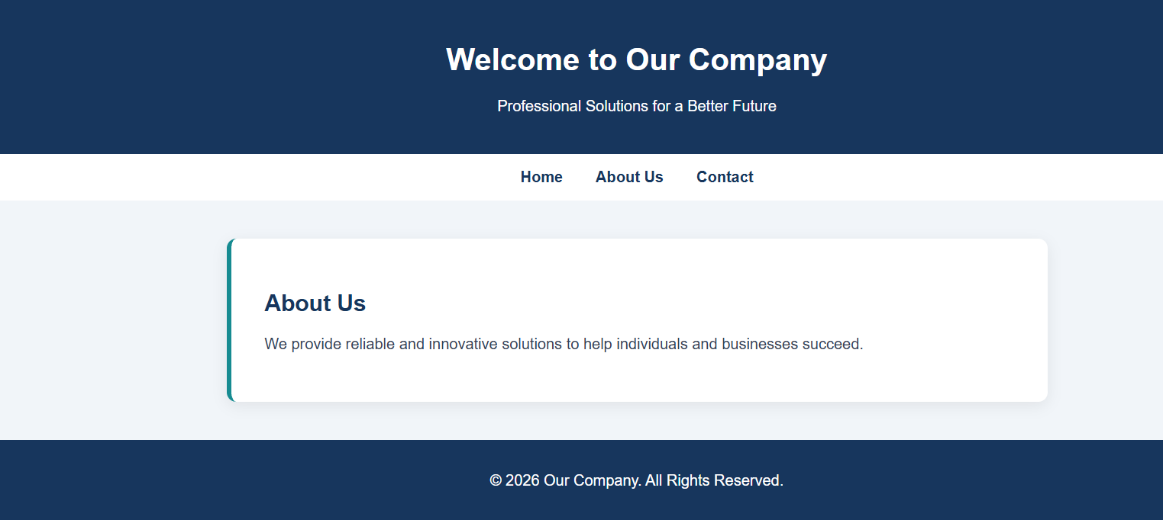

<!DOCTYPE html>
<html lang="en">
<head>
<meta charset="UTF-8">
<meta name="viewport" content="width=device-width, initial-scale=1.0">
<title>Company Website</title>

<style>
* {
box-sizing: border-box;
}

body {
margin: 0;
font-family: Arial, sans-serif;
background: #f1f5f9;
color: #334155;
}

header {
background: #17365d;
color: white;
padding: 25px;
text-align: center;
}

nav {
background: white;
padding: 15px;
text-align: center;
}

nav a {
color: #17365d;
text-decoration: none;
margin: 0 15px;
font-weight: bold;
}

nav a:hover {
color: #168b91;
}

main {
max-width: 900px;
margin: 40px auto;
padding: 0 20px;
}

section {
background: white;
padding: 35px;
border-radius: 10px;
box-shadow: 0 4px 15px #00000012;
border-left: 5px solid #168b91;
}

h2 {
color: #17365d;
}

footer {
background: #17365d;
color: white;
text-align: center;
padding: 18px;
}

@media (max-width: 600px) {
header h1 {
font-size: 25px;
}

nav a {
display: inline-block;
margin: 7px;
}

section {
padding: 22px;
}
}
</style>
</head>

<body>

<header>
<h1>Welcome to Our Company</h1>
<p>Professional Solutions for a Better Future</p>
</header>

<nav aria-label="Main navigation">
<a href="#home">Home</a>
<a href="#about">About Us</a>
<a href="#contact">Contact</a>
</nav>

<main id="home">
<section id="about">
<h2>About Us</h2>
<p>
We provide reliable and innovative solutions
to help individuals and businesses succeed.
</p>
</section>
</main>

<footer id="contact">
<p>© 2026 Our Company. All Rights Reserved.</p>
</footer>

</body>
</html>
3
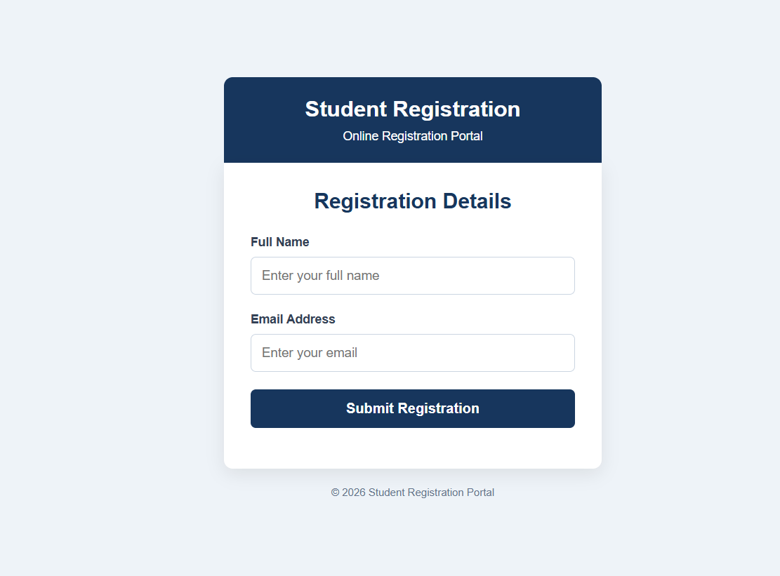

<!DOCTYPE html>
<html lang="en">
<head>
<meta charset="UTF-8">
<meta name="viewport" content="width=device-width, initial-scale=1.0">
<title>Student Registration Portal</title>

<style>
* {
box-sizing: border-box;
}

body {
margin: 0;
min-height: 100vh;
font-family: Arial, sans-serif;
background: #eef3f8;
color: #334155;
display: flex;
justify-content: center;
align-items: center;
padding: 20px;
}

.container {
width: 100%;
max-width: 430px;
text-align: center;
}

header {
background: #17365d;
color: white;
padding: 22px;
border-radius: 10px 10px 0 0;
}

header h1 {
font-size: 25px;
margin: 0 0 8px;
}

header p {
margin: 0;
font-size: 14px;
}

form {
background: white;
padding: 30px;
border-radius: 0 0 10px 10px;
box-shadow: 0 6px 20px #00000015;
text-align: left;
}

h2 {
text-align: center;
color: #17365d;
margin-top: 0;
margin-bottom: 25px;
}

label {
display: block;
margin-bottom: 8px;
font-weight: bold;
font-size: 14px;
}

input {
width: 100%;
padding: 12px;
margin-bottom: 20px;
border: 1px solid #cbd5e1;
border-radius: 6px;
font-size: 15px;
}

input:focus {
outline: 2px solid #168b91;
outline-offset: 1px;
}

button {
width: 100%;
padding: 13px;
background: #17365d;
color: white;
border: none;
border-radius: 6px;
font-size: 16px;
font-weight: bold;
cursor: pointer;
}

button:hover {
background: #168b91;
}

#message {
color: #16794b;
text-align: center;
margin-bottom: 0;
line-height: 1.5;
}

footer {
color: #64748b;
font-size: 12px;
margin-top: 20px;
}
</style>
</head>

<body>

<div class="container">

<header>
<h1>Student Registration</h1>
<p>Online Registration Portal</p>
</header>

<form id="registrationForm" action="/submit" method="POST">

<h2>Registration Details</h2>

<label for="name">Full Name</label>
<input
type="text"
id="name"
name="name"
placeholder="Enter your full name"
autocomplete="name"
required>

<label for="email">Email Address</label>
<input
type="email"
id="email"
name="email"
placeholder="Enter your email"
autocomplete="email"
required>

<button type="submit">Submit Registration</button>

<p id="message" role="status" aria-live="polite"></p>

</form>

<footer>
© 2026 Student Registration Portal
</footer>

</div>

<script>
const form = document.getElementById("registrationForm");
const message = document.getElementById("message");

// Frontend demonstration only
form.addEventListener("submit", function(event) {
event.preventDefault();

if (!form.checkValidity()) {
form.reportValidity();
return;
}

message.textContent =
"Form validated successfully. A backend is required to save your registration.";
});
</script>

</body>
</html>

